Virtual Server Monitoring and Performance Optimization

Project Documentation

1. Introduction

This project implements an end-to-end server monitoring data pipeline that ingests raw server logs, processes them through multiple transformation layers, and visualizes the insights through an interactive dashboard.
Due to the lack of access to cloud infrastructure, the pipeline was implemented locally using Microsoft SQL Server and Power BI, while still following the modern Bronze–Silver–Gold Medallion Architecture used in cloud data platforms.

2. Project Objectives
The main objectives of this project are:
- Ingest server performance data from a CSV dataset.
- Clean and transform raw data into structured datasets.
- Calculate key server performance metrics.
- Identify potential resource bottlenecks.
- Visualize server health and utilization trends through an interactive dashboard.

3. Technology Stack
Component | Tool Used
Database Engine | Microsoft SQL Server
Query Tool | SQL Server Management Studio
Data Source | CSV File
Data Transformation | SQL Stored Procedures
Visualization | Power BI

4. Data Architecture

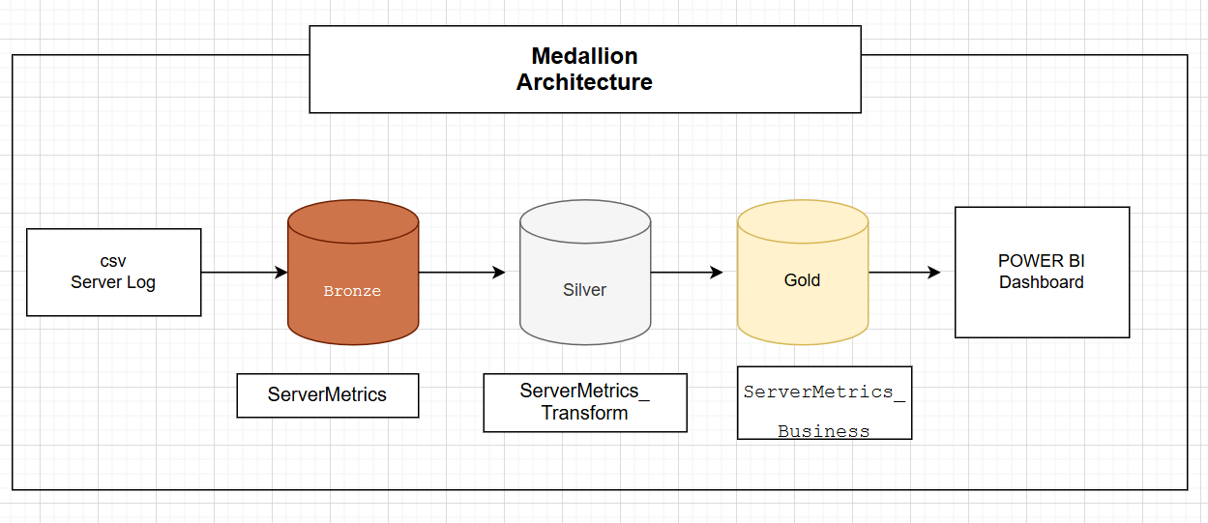

This project follows the Medallion Architecture:
Data Flow
CSV Dataset
→ Bronze Layer (Raw Data)
→ Silver Layer (Cleaned & Structured Data)
→ Gold Layer (Business Metrics & KPIs)
→ Power BI Dashboard

Bronze Layer
The Bronze layer stores raw ingested data exactly as received from the source file.
Purpose:
- Preserve original data
- Enable traceability
- Allow reprocessing if necessary
Table Created:
bronze.ServerMetrics
Data is ingested using the BULK INSERT command in SQL Server.

Silver Layer
The Silver layer performs data cleaning and transformation.
Key operations performed:
- Removal of unwanted characters in location fields
- Conversion of numeric fields from text to numeric data types
- Standardization of timestamp format
- Calculation of total operational hours
- Used data masking to hide sensitive data
Transformed data is stored in:
silver.ServerMetrics_Transform

Gold Layer
The Gold layer contains business-ready data optimized for reporting and analytics.
Additional metrics calculated include:
- Server Availability Percentage
- Total Network Traffic
- CPU Status Classification
- Memory Status Classification
- Overall Server Health Status
Output table:
gold.ServerMetrics_Business
This dataset is used directly for reporting in Power BI.

5. Data Transformation Logic
Several transformations were implemented to prepare data for analytics.

Data Type Conversion
Numeric metrics were converted from text format to numeric types for accurate analysis.
Example:
CPU_Utilization → DECIMAL
Memory_Usage → DECIMAL
Network_Traffic → FLOAT

Calculated Fields
Total Operational Hours
Total_Hours = Uptime_Hours + Downtime_Hours
Server Availability
Availability % = (Uptime_Hours / Total_Hours) × 100
Total Network Traffic
Network_Traffic_In + Network_Traffic_Out

6. Server Health Classification
Server health indicators were created based on CPU and Memory usage.

CPU Status
CPU Usage | Status
> 85% | Critical
70–85% | High
< 70% | Normal

Memory Status
Memory Usage | Status
> 90% | Critical
75–90% | High
< 75% | Normal

Overall Server Status
- Warning → If CPU or Memory exceeds critical thresholds
- Healthy → Otherwise

7. Power BI Dashboard
An interactive dashboard was created using Power BI to visualize server performance.

Key Performance Indicators (KPIs)
- Average CPU Utilization
- Average Disk I/O
- Average Memory Usage
- Average Server Availability
- Total Number of Servers

Visualizations Included
- CPU & Memory Trend Analysis
Displays monthly CPU and memory usage trends.
- Network Traffic Analysis
Shows network traffic distribution across countries.
- OS Usage Analysis
Compares CPU and memory usage across different operating systems.
- Server Status Monitoring
Displays the number of healthy and warning servers.
- CPU Status Distribution
Shows the distribution of servers under Normal, High, and Critical CPU load.
- Server Details Table
Provides server-level operational information.

Filters
Interactive filters were implemented for:
- Hostname
- Admin Name
These filters allow users to analyze performance for specific servers or administrators.

8. Key Insights
From the dashboard analysis:
- Average CPU utilization across servers is approximately 57%, indicating moderate load.
- Average memory usage is around 60%, suggesting stable resource consumption.
- Most servers are categorized as Healthy, with a small percentage in the Warning category.
- Certain countries show higher network traffic, indicating regional infrastructure load.

11. Conclusion
This project demonstrates the implementation of a server monitoring data pipeline using SQL-based ETL processes and interactive data visualization.
The solution successfully:
- Processes raw server logs
- Calculates meaningful operational metrics
- Detects potential performance issues
- Provides actionable insights through dashboards
The architecture follows modern data engineering principles and can easily be extended to cloud-based platforms.

